Study Trip to South Africa

Prevention, Preparedness and Response to Forest and Land Fires
GIZ and UNOPS/GAMBUT recently facilitated a study trip for forest and land fire stakeholders to KwaZulu-Natal and Mpumalanga in South Africa from 20-28 August 2016. Participants from South Sumatra were Achmad Taufik (Head of the Regional Technical Implementation Unit from the Palembang Forestry Office) and Didik Suprijono (Forest and Land Fires Section Head from the Sumatra Region Climate Change and Forest and Land Fire Management Agency). The 19 participants involved came from the Ministry of Environment and Forestry (KLHK), the Peatland Restoration Agency (BRG), the National Disaster Management Agency (BNPB), the Ministry of Political Affairs and Human Rights, and regional officials from Riau, West Kalimantan and Central Kalimantan provinces, as well as CCROM IPB, UNOPS, and GIZ.
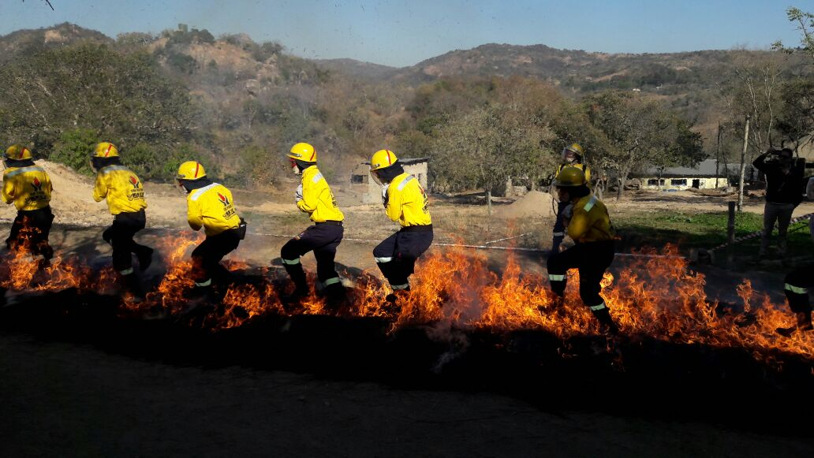
Photo 1. Fire fighting team (Kishugu) training in Nelspruit

The background to the trip was the forest and land fire occurrences that always affect Indonesia, particularly its peatlands in Sumatra and Kalimantan. These fires have impacted significantly on biodiversity loss and land use change, not to mention their health impacts and the greenhouse gas emissions they cause every year.
Major issues constituting challenges to Indonesia in relation to managing forest and land fires are weak coordination and overlapping responsibilities between stakeholders, a lack of awareness among communities and companies regarding forest and land fire risk, weak law enforcement, unclear chains of command in preventing and responding to forest and land fires, human resources development, and a lack of adequate equipment.

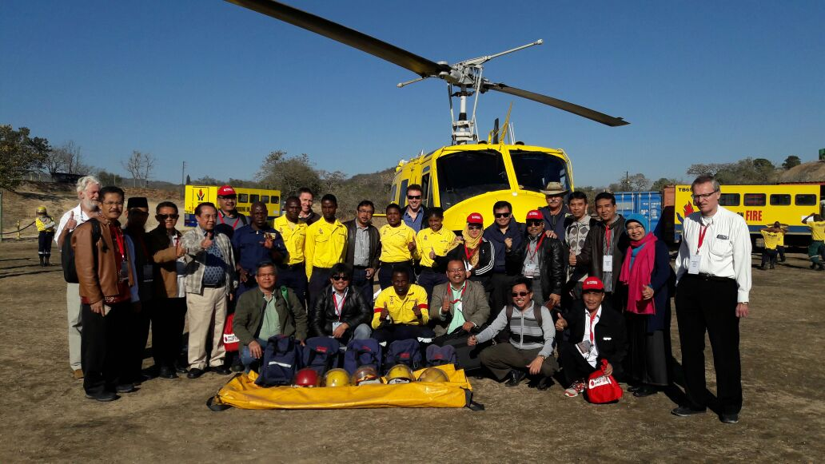
Photo 2. Group photo of study trip participants from Indonesia with the Nelspruit Fire Fighter Team

In South Africa, meanwhile, forest and land fires are a natural phenomenon that occur annually during the hot season and have resulted in South African ecosystems becoming fire adapted; meaning the region burns regularly to maintain a balanced environmental cycle. Nevertheless, the fires still need to be controlled and supervised to suit land use, and not threaten communities’ safety, homes and livelihood sources. To do this, South Africa has developed a professionally integrated fire management system; the ‘Working on Fire’ (WoF) program.
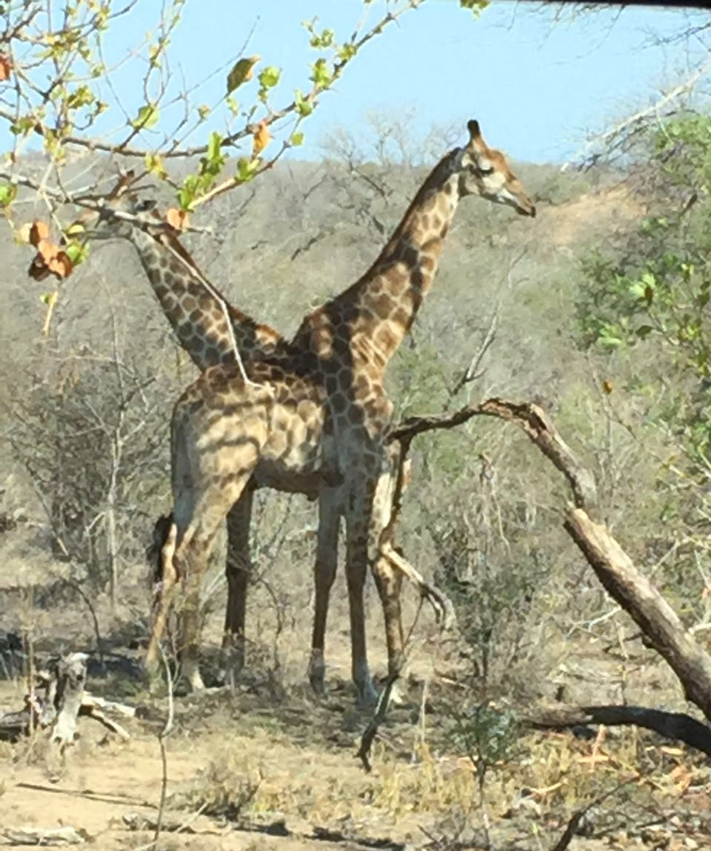
Below is a testimony from a local youth who works as a firefighter in WoF.
WoF is a local government funded program for recruiting and training young local men and women. Lessons from the WoF activity model in South Africa are: (a) recommendations for recruitment systems and firefighting training, (b) combination with social development efforts, (c) funding mechanisms, and (d) raising community awareness by involving local youth. The WoF program has brought significant impacts for its crews. The program answers economic issues affecting individuals in the country, while simultaneously saving the environment from the threat of forest and land fires.

Photo 3. Wildlife in Kruger National Park

“It all began on 24 January 2011, when a friend of mine came to my front door that afternoon and told me there was a job vacancy to work with Working on Fire. Before that I’d spent my time job hunting.
I immediately drew up and prepared my CV and other things needed to apply for the job and rushed off to the Ficksburg Showground where recruitment was taking place. I didn’t know what was expected at the time. When I arrived there, I saw loads of young people had come, which was due to the fact that our country’s facing very high levels of unemployment. So I said to myself, “This is my chance, my destiny and my fate as well …”
I finished the fitness test and the results were impressive, then I went for the interview and as it turned out it really was my fate. Once I was accepted into the program, I worked as a firefighter for a year. Then in 2011, through hard work and determination, I was promoted to Type 2 Crew Leader.
The background to my life can be defined in two words: someone from a poor background whose life changed after joining the program. With the salary I get for working with Working on Fire, I can do the following things: (a) stop hunger when it comes, (b) buy furniture for my parents, (c) get a driving license, and (d) buy my own car.
I’ve changed from being “nobody” to becoming “someone” now. I’ve moved from a world of despair to a world full of hope, where I’ll hear only good news. Now, today, I’ve finished the Type l Crew Leader program and I’m looking forward to seeing my future continuing with Working on Fire”.

-------------------
Contacts:
Ahmad Taufik - Head of the Palembang Forestry Office Regional Technical Implementation Unit (taufikahmad383@yahoo.com)

Didik Suprijono – Forest and Land Fires Section Head (didiksuprijono@gmail.com)

Nyimas Wardah (nyimas.wardah@giz.de)

