FGD ON IDENTIFYING AND MAPPING SUMATRAN ELEPHANT AND TIGER HABITAT ENCLAVES IN SOUTH SUMATRA

The FGD on “Mapping Sumatran Elephant and Tiger Habitat Enclaves in South Sumatra” took place on 8 August 2016 with more than 50 participants attending from various government institutions, the private sector, universities and related NGOs in South Sumatra. The activity, which took place on collaboration between the South Sumatra Natural Resources Conservation Agency (BKSDA), Sriwijaya University and GIZ-Bioclime, was opened by the Head of the South Sumatra BKSDA, Nunu Anugerah, M.Sc.
The activity was warmly welcomed by all parties as an effort for preserving these two vital key species and for the continued preservation of forest ecosystems in South Sumatra. In his opening address, Nunu Anugerah explained that these two species are protected and have critically endangered status. Further, both constitute umbrella species, which means efforts for their conservation will help save other biodiversity within the ecosystem, so that other key species can eventually be saved. The expectation was that conservation efforts for these two species will become stepping stones for preparing and planning further action plans for other endangered species.
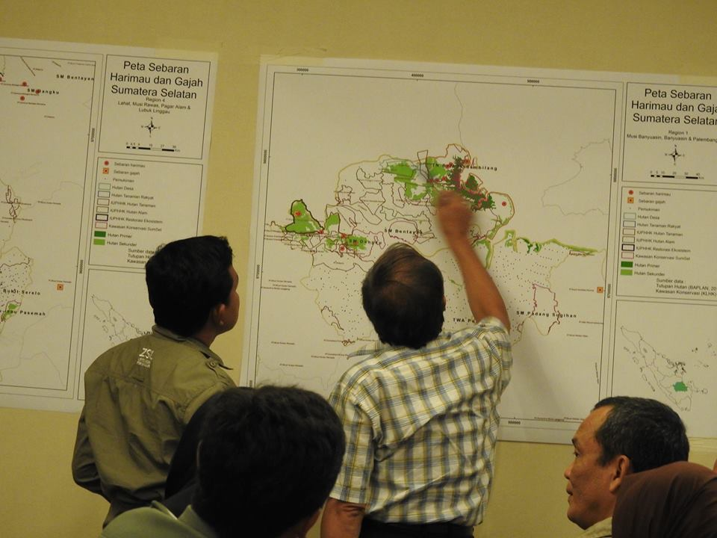

Photo 1. Identifying Sumatran tiger and elephant habitat enclaves
Also in attendance at the meeting were professionals and speakers with expertise in the conservation of these two species. These included Yoan Dinata (FHKI/ZSL Indonesia, Doni (FKGI/FFI), Sunarto (FKGI/WWF) and representatives from APHI. Acting as moderator was Prof. Lilik Budi Prasetyo from the Bogor Agriculture Institute (IPB). During the discussion process, participants were divided into 2 (two) groups based on geographic region; the northern and southern parts of South Sumatra.
The one-day FGD produced data in the form of information on distribution of the two species from stakeholders in attendance representing each of their institutions and work areas. This outcome was extremely important considering available data needs updating and reverification in order to supplement missing or unavailable data for South Sumatra.
After the FGD, in a limited meeting on 12 August 2016 an agreement was reached to discuss follow-up plans and to make an action plan for Sumatran tiger and elephant conservation. The meeting also established which areas constitute tiger and elephant habitat enclaves. For the Sumatran tiger, provisional outcomes established 8 habitat enclaves, with another 8 also established for elephant habitat enclaves distributed throughout South Sumatra. With the establishment of these habitat enclaves in the South Sumatra region, further steps can be taken to determine which habitat enclaves require surveys to verify the presence of these two species, and which enclaves require monitoring. During the meeting a framework for preparing draft documents was designed along with proposals for future action plans for the preservation of these two key species.
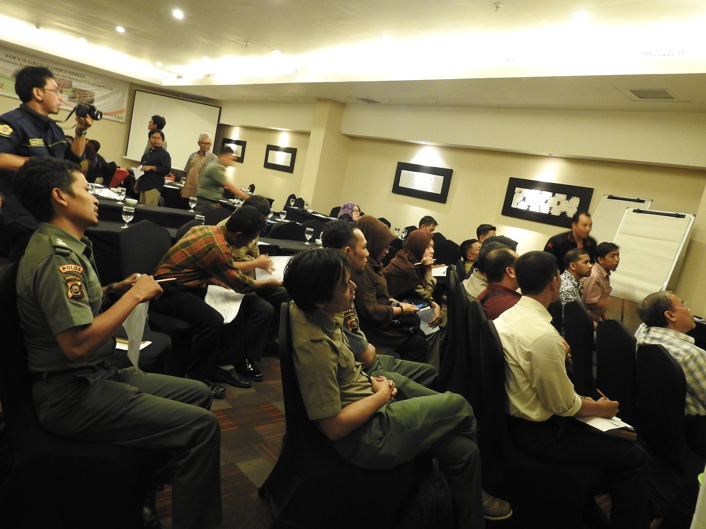
Photo 2. The discussion process for identifying tiger and elephant habitat enclaves

Contacts:
Hendi Sumantri : hendi.sumantri@gmail.com
Rendra Bayu Prasetyo : rendrabayuprasetyo1@gmail.com

Editor:
Nyimas Wardah : nyimas.wardah@giz.de

